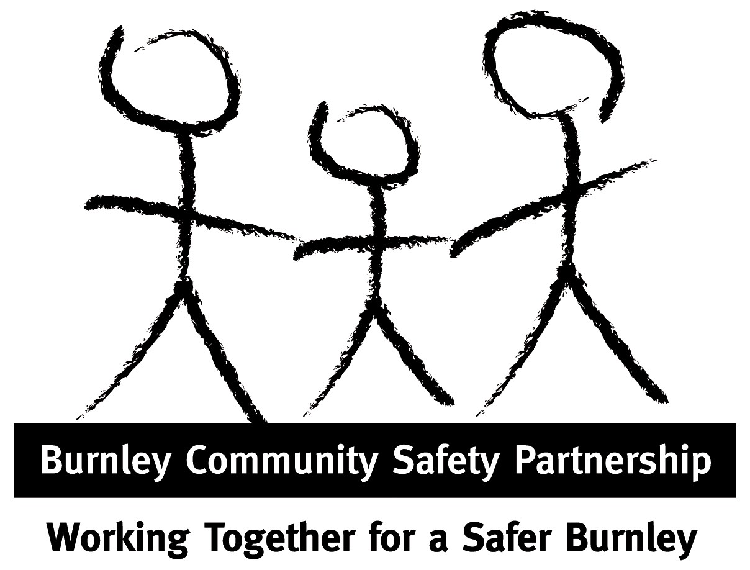 Burnley Domestic Abuse Newsletter 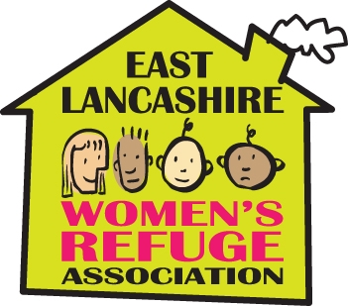

Welcome to the new bi-monthly Burnley Domestic Abuse Forum Newsletter August 2010
Newsletter 1

This e-newsletter will keep you updated on relevant local and national news in relation to domestic abuse & violence. Please help us to circulate this as widely as possible by sharing with your colleagues.

We would like to use this newsletter as an opportunity to showcase the work that partner agencies are doing in relation to domestic abuse, so please let us know if you would like us to include information about your service in a future issue, or for further information about anything in this newsletter please contact:
Louise Howorth, Domestic Violence Coordinator at LHoworth@burnley.gov.uk

Get Involved: Burnley Domestic Abuse Forum is a multi-agency group aimed at sharing information about the work being done to tackle domestic abuse in Burnley. Next Burnley DA Forum Meeting: 14th September 2010, 12.15 pm - 2pm, Burnley Town Hall, (buffet lunch available from 11.45am)

Domestic Abuse Perpetrator Treatment Programme
It is widely recognised that in order to effectively tackle the existence of domestic violence within our community we need to target the perpetrators. Burnley has recently received funding from the Lancashire Partnership Against Crime (LANPAC) to provide a Domestic Abuse Perpetrator Treatment Programme for men living in Burnley & East Lancashire. The programme is designed to be a 25 session Cognitive Behavioural Therapy (CBT) based programme, which was developed and will be delivered by the Consultant Chartered Forensic Psychologist at Forepsych Ltd. The programme is aimed at supporting the work of the Public Protection Unit, reducing offending and repeat victimisation and increasing the safety of vulnerable members of the community and their children. The programme has been designed to integrate with existing services, and will work in association with local Domestic Abuse support services, to ensure a separate and confidential support service for the partners and ex-partners of the men on the programme. A progress update will be provided in the next DA Newsletter.
June 2010 - the first Lancashire Safeguarding Children Board newsletter was published, focusing on Serious Case Review findings. Out of the 9 Serious Case Reviews completed, two thirds involved the death of a child, whilst one third related to a life-threatening incident where there had been issues about inter-agency working.

The findings show that the issues that were most prevalent in families that were the subject of Serious Case Reviews in Lancashire were alcohol abuse and domestic abuse, along with mental health and in most of the SCR's, there was more than one issue present, and alcohol abuse, domestic abuse and mental illness were often found together.
Updates about Serious Case Reviews are to be published quarterly.
For more details: http://www.lancashire.gov.uk/education/safe_child_board/

Upcoming Training for Front-line Staff & Managers:
Level 1 Domestic Abuse Awareness Training: 30th September & 25th November 2010
Level 2 Impact of Domestic Abuse on Children & Young People Training: 26th August & 28th October 2010
For more information & to book a place contact Louise Howorth - LHoworth@burnley.gov.uk

Did you know? …..

4 out of the 5 of the Children’s Trusts in East Lancashire listed Domestic Abuse as their priority issue & Burnley Children’s Trust Partnership provides funding for SafeNet DV Helpline and Community Based Service.

Useful Contact Numbers and Web links

LOCAL

East Lancashire Women’s Refuge Association (ELWRA) 01282 414130
24-Hour Refuge accommodation and support service for women & children escaping domestic violence/abuse.
www.elwra.org.uk

ELWRA Safenet 07866 510 728
Domestic Violence & Abuse Helpline and Community Based Service (Mon-Fri, 10am – 5pm)
Drop-in service available at Children’s Centres, Health Centres and other community venues in Burnley and Pendle.

Sanctuary Project 07866 510 728
Target hardening (security improvements to the homes of victims of domestic violence)

One Burnley Woman’s experience: “I have been receiving regular support from SafeNet. They helped me get legal advice and helped me with housing, and I have just moved into my own home. They helped me to feel safe in my home by having security installed, locks changed etc. Most importantly they listened.”

NATIONAL

Broken Rainbow 0845 2604460
(Monday 2-8pm, Wednesday 10-1pm, Thursday 2-8pm)
Supports lesbian, gay, bisexual and transgender people who are experiencing domestic violence
www.broken-rainbow.org.uk

Help and support for children and young people living with domestic violence
www.thehideout.org.uk

Freephone 24-Hour National Domestic Violence Helpline 0808 2000 247
Run in partnership between Women’s Aid and Refuge.
www.womensaid.org.uk

Freephone National Men’s Advice Line 0808 801 0327
For male victims in a heterosexual, gay, bi-sexual or transgender relationships
www.mensadviceline.org.uk

RESPECT Phoneline 0845 122 8609
For perpetrators of domestic violence

Did you know? …..

During this years Community Safety Partnership World Cup DV Campaign, SafeNet DV Helpline saw an increase in referrals, with June seeing a 32% increase in contacts in comparison to May. Police call outs to DV incidents in June did not see any significant increase. This rise in calls to SafeNet may have been a result of the awareness raising work carried out during the campaign, encouraging victims to seek help sooner, and reducing the need for crisis interventions by other services such as the Police.

